**calculus**

**Parastoo masoodi (20105)**

1. Researchers measured the blood alcohol concentration (BAC) of eight adult male subjects after rapid consumption of *30* mL of ethanol (corresponding to two standard alcoholic drinks). The table shows the data they obtained by averaging the BAC (in mgymL) of the eight men.

**a**. Below is the graph of BAC as a function of time t.

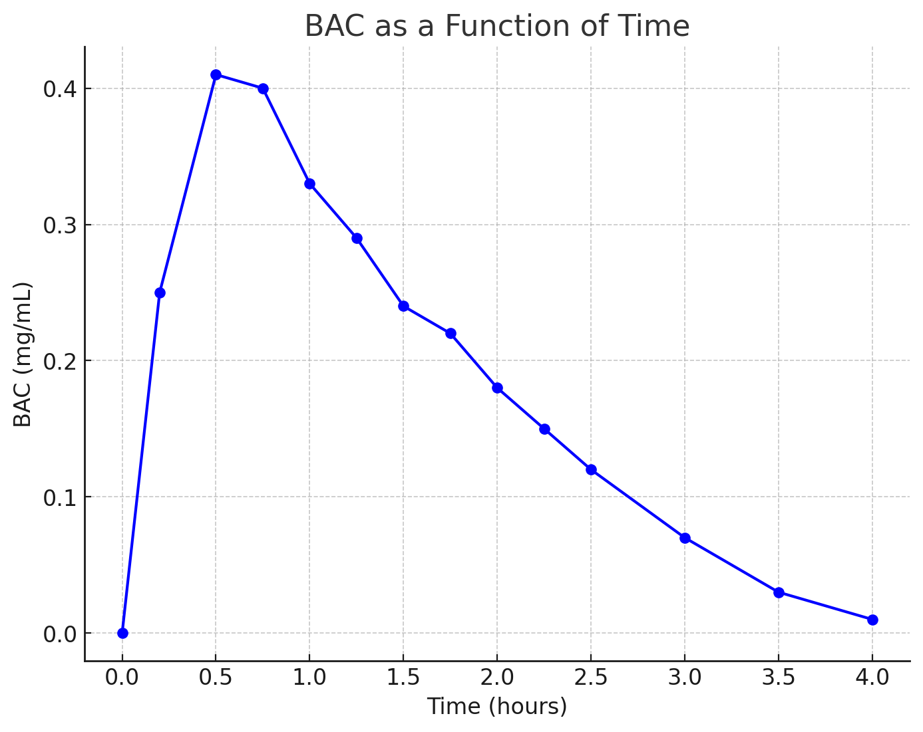

**b**. From the graph, we can observe the following pattern:

* **Initial increase:** The BAC rises quickly within the first 0.5 hours, reaching a peak of 0.41 mg/mL. This indicates that alcohol absorption into the bloodstream happens rapidly soon after consumption.
* **Peak and decline:** After 0.5 hours, BAC starts to decrease, indicating that the body begins metabolizing the alcohol. The concentration steadily decreases over the next few hours.
* **Steady decline:** By 1 hour, the BAC is reduced and continues to drop until it reaches near-zero values after 4 hours.

This suggests that alcohol effects peak relatively quickly and then gradually drop over the next few hours.

|  |  |
| --- | --- |
| ***t* (hours)** | **BAC** |
| 0 | 0 |
| 0.2 | 0.25 |
| 0.5 | 0.41 |
| 0.75 | 0.40 |
| 1 | 0.33 |
| 1.25 | 0.29 |
| 1.5 | 0.24 |
| 1.75 | 0.22 |
| 2.0 | 0.18 |
| 2.25 | 0.15 |
| 2.5 | 0.12 |
| 3.0 | 0.07 |
| 3.5 | 0.03 |
| 4.0 | 0.01 |

1. Find an expression for the function whose graph is the given curve in the top half of the circle , and then plot it in Excel or any computer language.

By the given equation, we need to find an expression for the function that represents the top half of the circle.

+ = 4

= 4 −

y − 2 = ±

y − 2 =

y =

y = is the equation of the top half of the circle.

**Plot the function:**

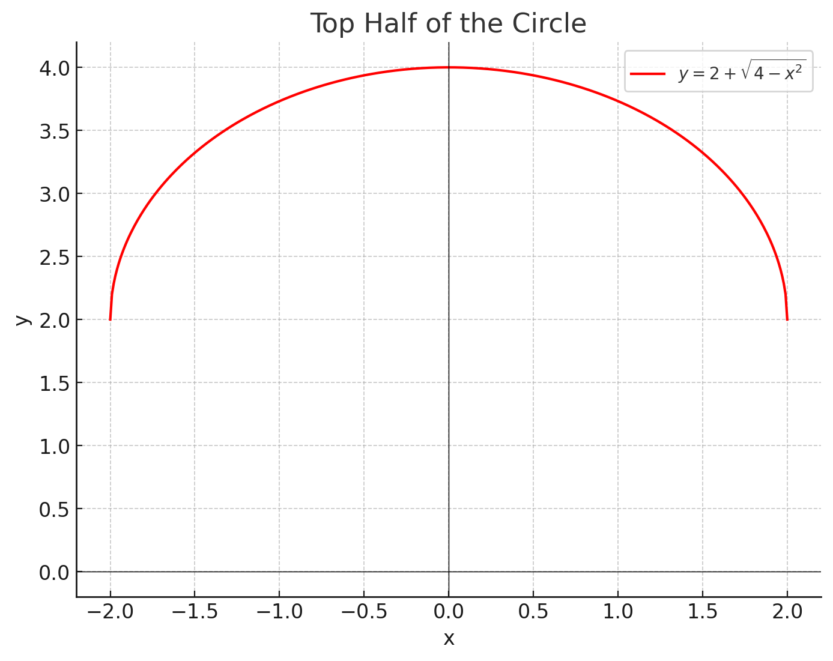

This graph represents the upper portion of the circle centered at (0,2) with a radius of 2.

1. In a certain country, income tax is assessed as follows. There is no tax on income up to *$10,000*. Any income over *$10,000* is taxed at a rate of *10%*, up to an income of *$20,000*. Any income over *$20,000* is taxed at *15%*.

**a**. The income tax system is structured as follows:

* For income I ≤ 10,000, the tax rate R = 0%.
* For income 10,000 <I ≤20,000, the tax rate R = 10%.
* For income I > 20,000, the tax rate R = 15%.

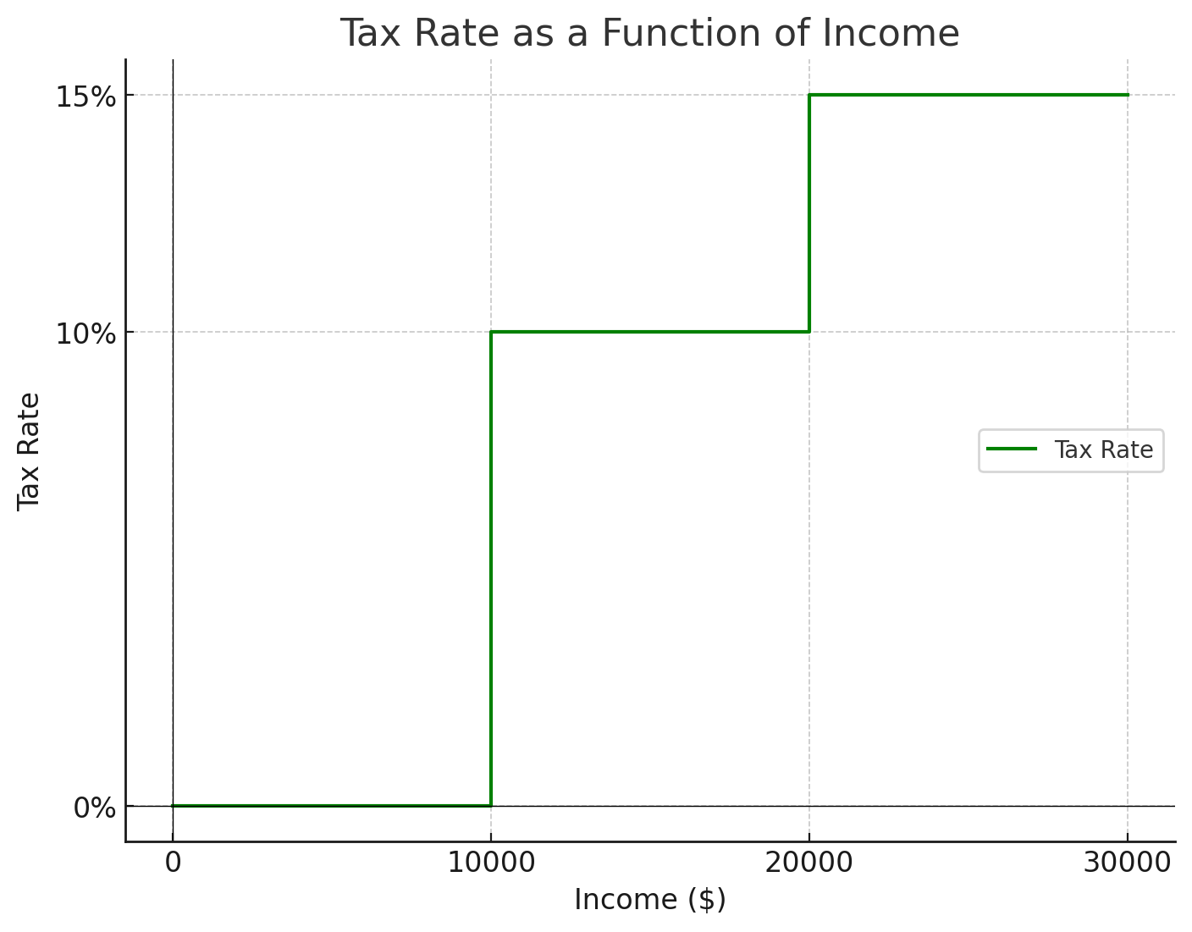

Here is the graph of the tax rate R as a function of income I.

**b**. To calculate the tax:

* **Income of $14,000**:
  + For the first $10,000, the tax is $0.
  + For the next $4,000 (which is taxed at 10%), the tax is 0.10×4,000=4000.10 \times 4,000 = 4000.10×4,000=400.

Therefore, the total tax for an income of $14,000 is **$400**.

* **Income of $26,000**:
  + For the first $10,000, the tax is $0.
  + For the next $10,000 (which is taxed at 10%), the tax is 0.10×10,000=1,0000.10 \times 10,000 = 1,0000.10×10,000=1,000.
  + For the remaining $6,000 (which is taxed at 15%), the tax is 0.15×6,000=9000.15 \times 6,000 = 9000.15×6,000=900.

Therefore, the total tax for an income of $26,000 is **$1,900**.

**C**.

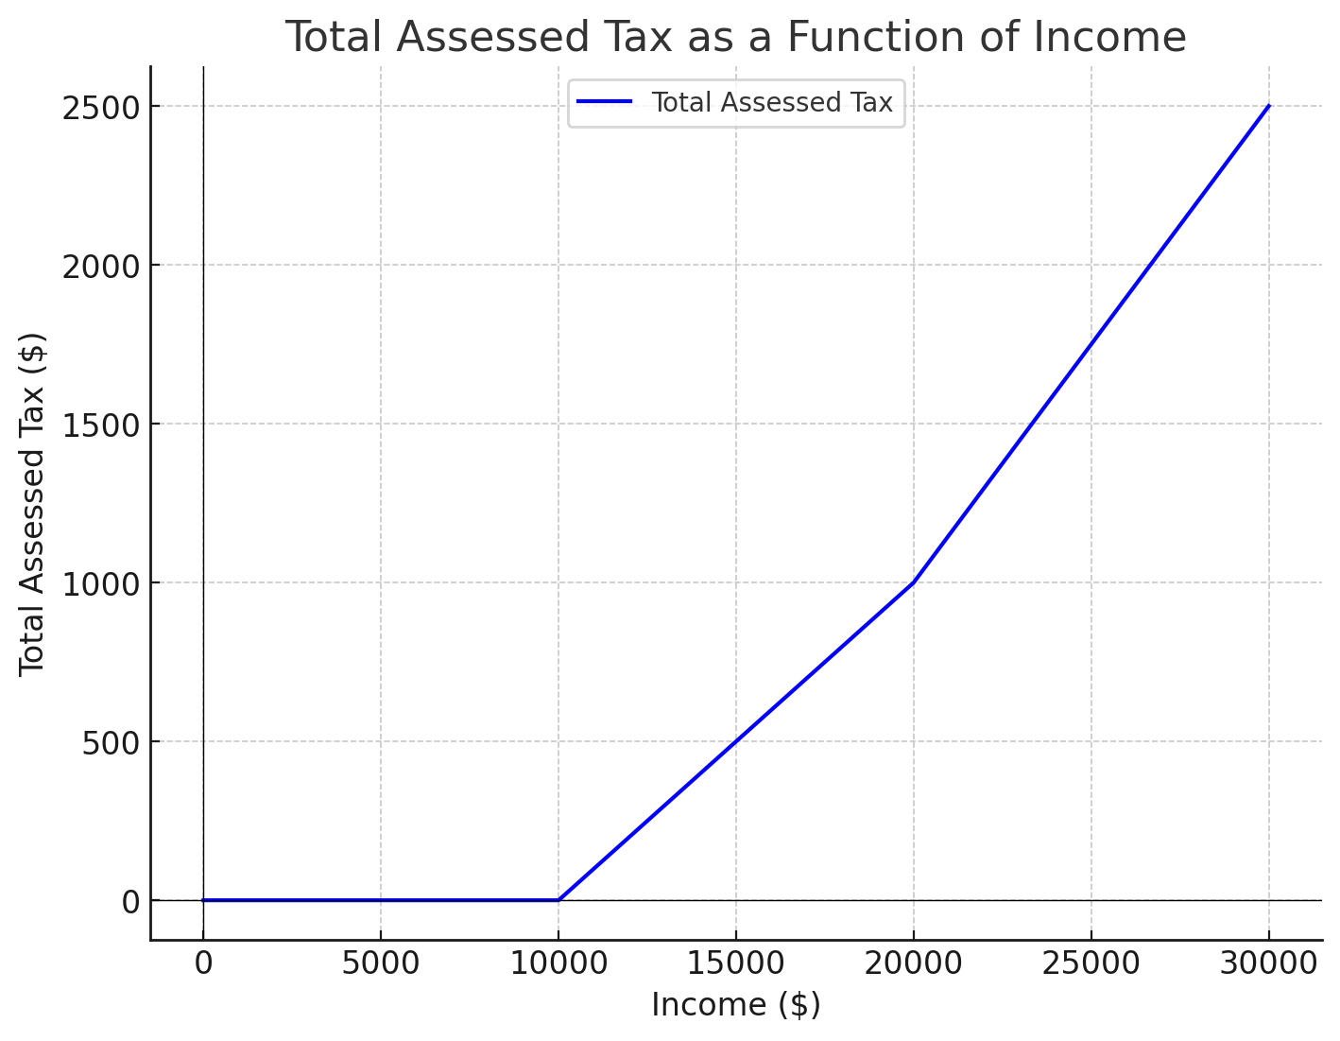

Here is the graph of the total assessed tax TTT as a function of income III. The tax increases progressively as the income rises, with distinct linear segments corresponding to the different tax brackets:

* No tax for income up to $10,000.
* A 10% tax between $10,000 and $20,000.
* A 15% tax for income above $20,000.

1. Decide what type of function you might choose as a model for the given data as follows by selecting fitting function in Excel. Of course, before fitting, the x-y values should be created based on your observation.

Function Models for Each Plot

#### **a. Increasing Pattern:**

* **Exponential function**: The graph seems to show exponential growth. The general form of an exponential function is:

y =

where a and b are constants. Exponential functions are commonly used to model rapid growth, as seen in plot (a).

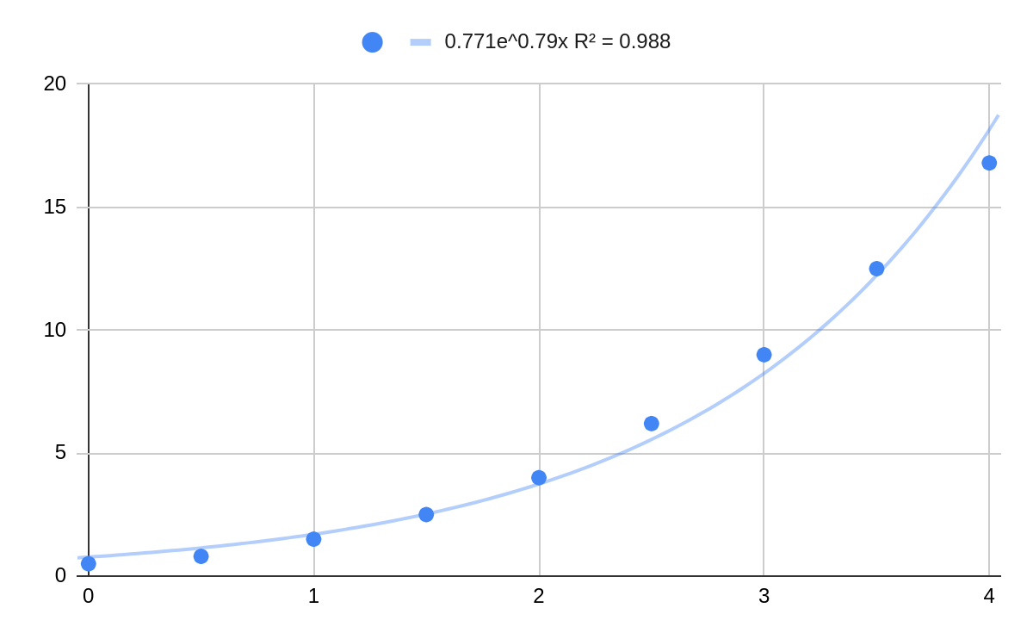

The chart represents an exponential growth pattern with the equation . The value of 0.988 suggests that this model closely fits the data, showing a rapid increase in y as x increases.

#### **b. Decreasing Pattern:**

* **Exponential decay**: The graph appears to show exponential decay. The general form of an exponential decay function is:

y =

This type of function is used when a quantity decreases rapidly at first and then levels off, which matches the behavior in plot (b).

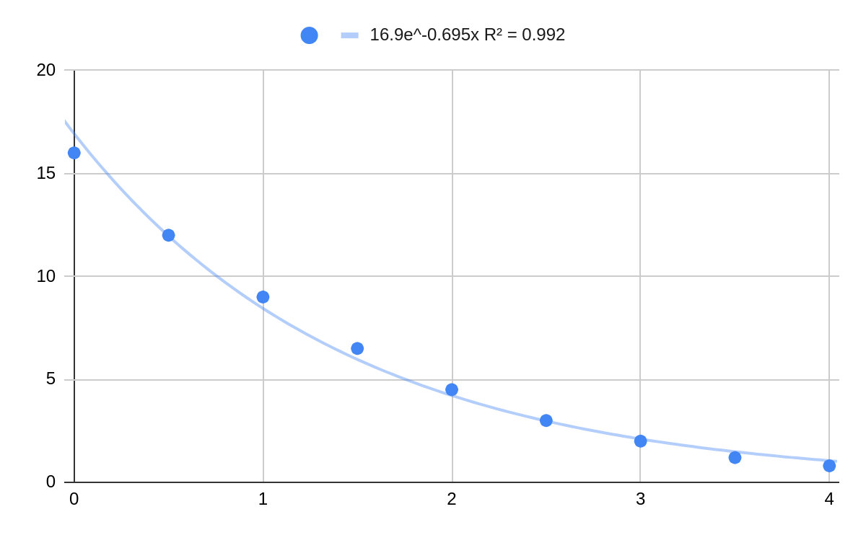

The chart represents an exponential decay pattern with the equation . The value of 0.992 suggests a very accurate fit, capturing the sharp decrease in y as x increases.

1. Anthropologists use a linear model that relates human femur (thighbone) length to height. The model allows an anthropologist to determine the height of an individual when only a partial skeleton (including the femur) is found. Here we find the model by analyzing the data on femur length and height for the eight males given in the following table.

**a**.

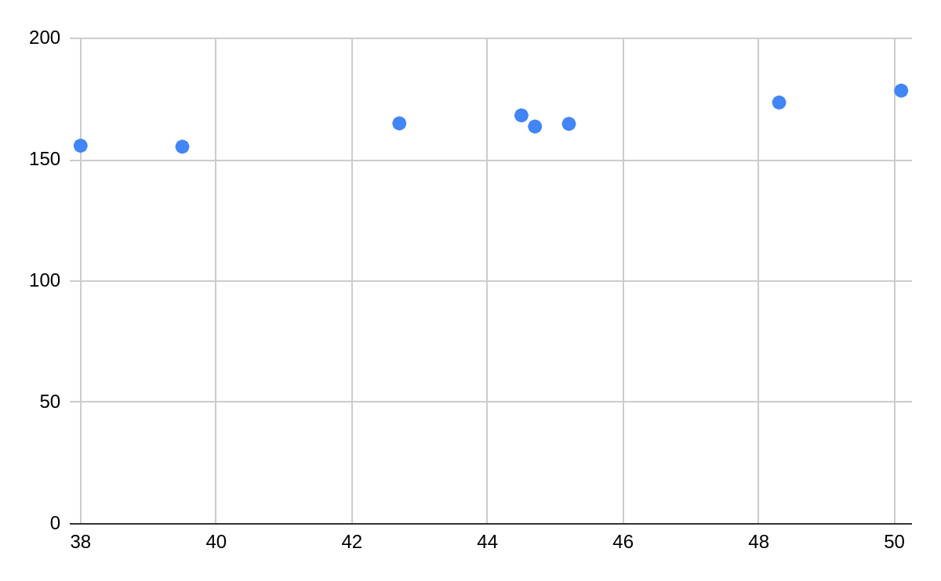

The scatter plot visualizes the relationship between femur length (cm) and height (cm) for eight male individuals. The X-axis represents the femur length, while the Y-axis represents the corresponding height.

**b**.

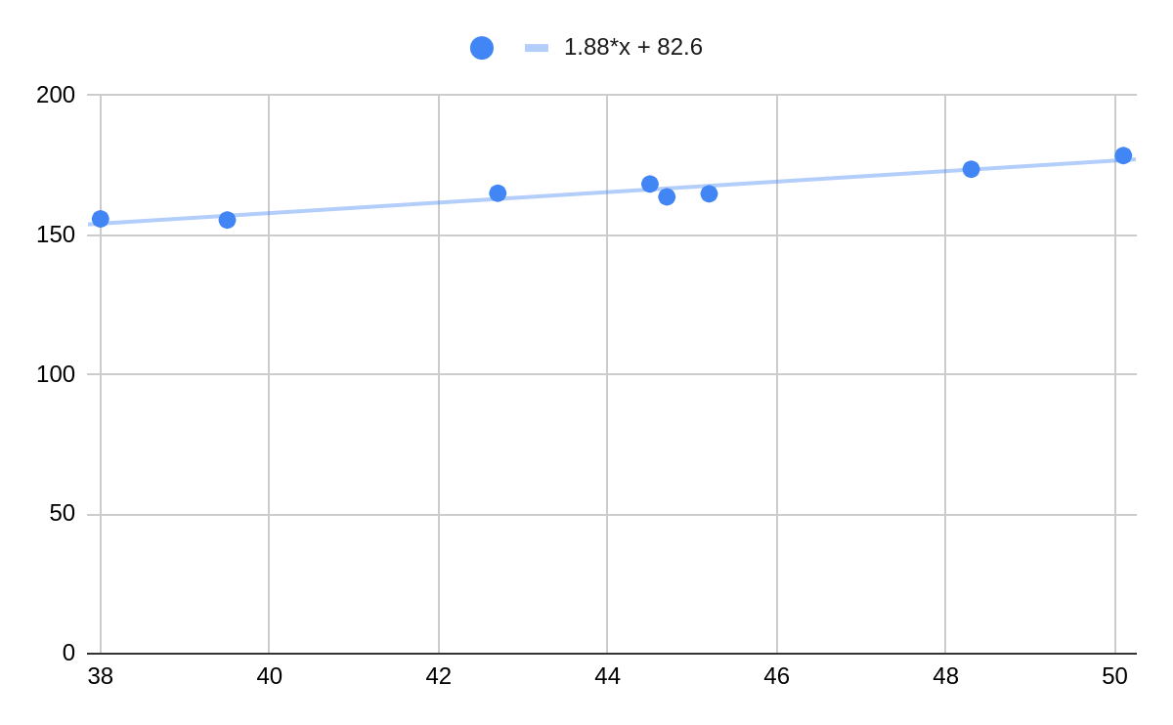

The scatter plot visualizes the relationship between femur length (cm) and height (cm) for eight male individuals. The fitted linear regression trendline, represented by the equation y=1.88x+82.6y = 1.88x + 82.6y=1.88x+82.6, indicates a positive correlation between femur length and height. The slope of 1.88 suggests that for every 1 cm increase in femur length, the height increases by approximately 1.88 cm.

**c**. Using the linear regression equation obtained from Part B, y = 1.88x + 82.6, we can estimate the height of a person with a femur length of 53 cm.

Substitute x = 53 into the equation:

y = 1.88(53) + 82.6 = 99.64 + 82.6 = 182.24 cm

Therefore, the estimated height of a person with a femur length of 53 cm is **182.24 cm**.

|  |  |
| --- | --- |
| **Femur length**  **(cm)** | **Height**  **(cm)** |
| 50.1 | 178.5 |
| 48.3 | 173.6 |
| 45.2 | 164.8 |
| 44.7 | 163.7 |
| 44.5 | 168.3 |
| 42.7 | 165.0 |
| 39.5 | 155.4 |
| 38.0 | 155.8 |

1. The table shows the mean (average) distances *d* of the planets from the sun (taking the unit of measurement to be the distance from the earth to the sun) and their periods *T* time of revolution in years).

**a**.

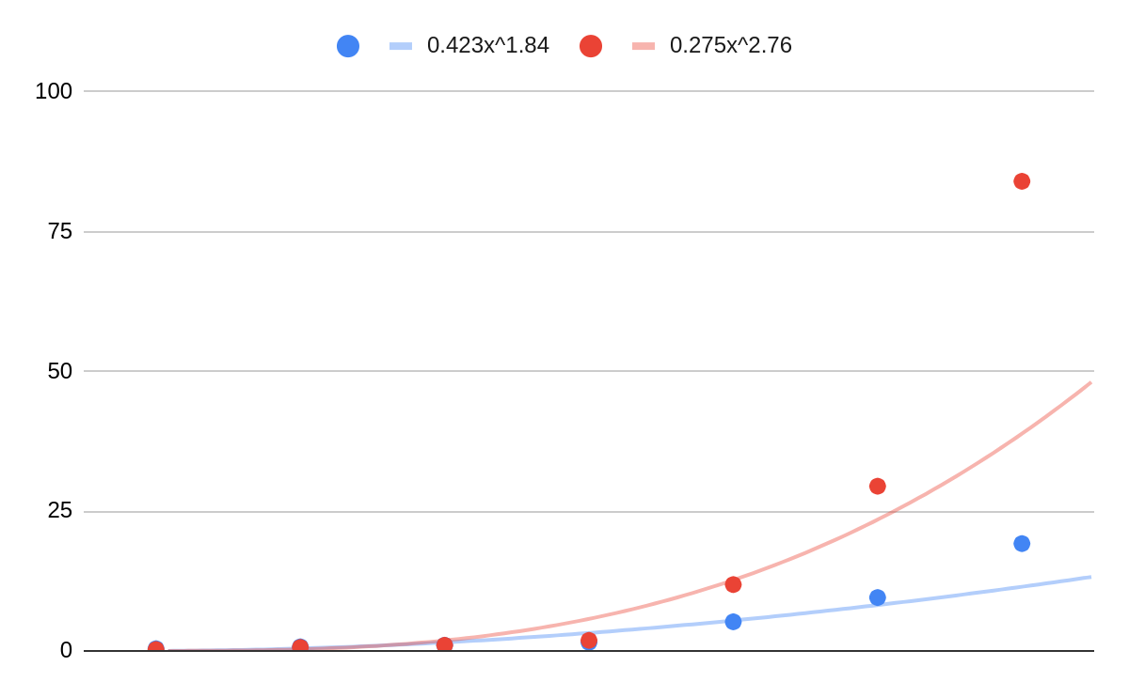

The scatter plot shows the relationship between the mean distance d of planets from the sun and their periods of revolution T. A power model fits the data, indicating that the period of revolution increases as the mean distance from the sun increases. The exponent 1.84 is reasonably close to Kepler's expected value of 1.5 suggesting that the model is consistent with Kepler's Third Law, though there is a slight deviation.

**b**. Kepler’s Third Law of Planetary Motion states that:

T2 ∝ d3

This means that the square of the period of revolution T is proportional to the cube of the mean distance d from the sun. Mathematically, this can be expressed as:

T2 = k⋅d3

where kkk is a constant. This law implies that as the distance d increases, the orbital period T should increase as well, following a specific cubic relationship.

**c**. The power model derived from the data in Part A is T = 0.423⋅. According to Kepler’s Third Law, we expect the exponent to be 1.5 because T2 ∝ d3, which simplifies to T ∝ d1.5.

In our model, the exponent 1.84 is reasonably close to the theoretical value of 1.5 This suggests that the model is largely consistent with Kepler’s Third Law, although there is some deviation. The data supports the idea that the period of revolution increases as the mean distance from the sun increases, as predicted by Kepler's Third Law. However, the deviation in the exponent indicates that the relationship is not perfectly exact for the given data set, likely due to real-world complexities.

|  |  |  |
| --- | --- | --- |
| **Planet** | **d** | **T** |
| Mercury | 0.387 | 0.241 |
| Venus | 0.723 | 0.615 |
| Earth | 1.000 | 1.000 |
| Mars | 1.523 | 1.881 |
| Jupiter | 5.203 | 11.861 |
| Saturn | 9.541 | 29.457 |
| Uranus | 19.190 | 84.008 |
| Neptune | 30.086 | 164.784 |

1. How is the graph of related to the graph of *f(x)?*

**a**.  
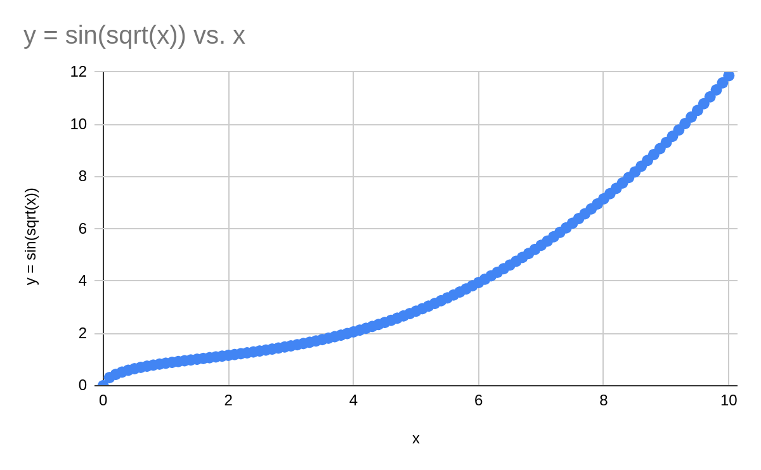

The graph represents the function y=sin⁡(), where xxx ranges from 0 to 10. The function increases gradually at first and then more rapidly as x increases. This is due to the square root function growing slowly for smaller x values, while the sine function begins to rise more sharply as ​ increases. The graph starts at (0,0) and shows a smooth, upward trend, reflecting the combined influence of the square root and sine functions.

**b**.   
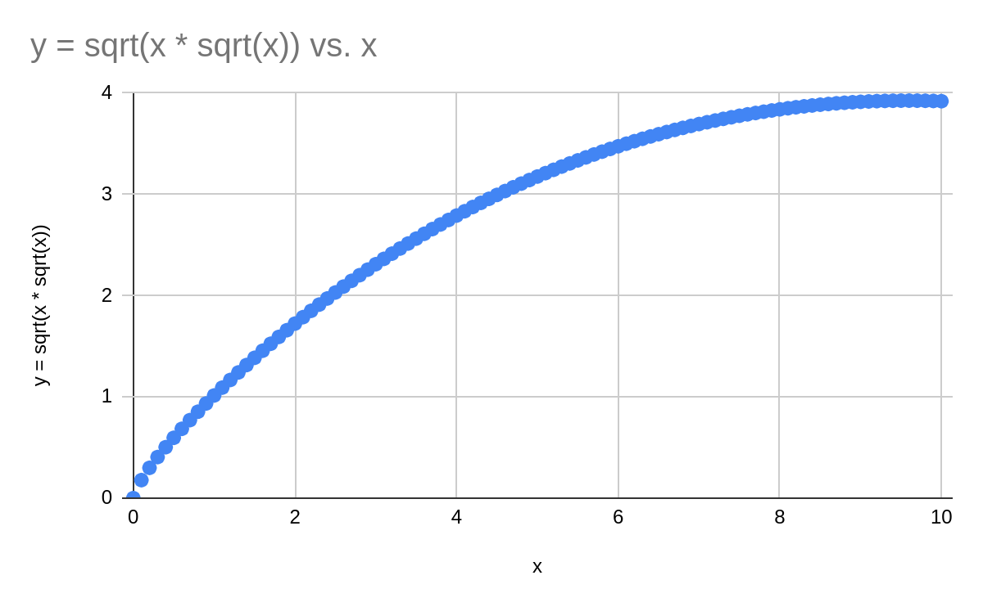

This graph shows the function y = ​​, where x ranges from 0 to 10. The curve starts at (0,0) and increases gradually, reflecting the influence of the square root operations. As x increases, the growth of y becomes slower, but it continues to rise throughout the given range. This is characteristic of the function involving nested square roots, which grow steadily but more slowly as x becomes larger.

1. Use the given graphs of *f* and *g* to evaluate each expression or explain why it is undefined.

**a**. ( g∘f ) (6)

This represents g(f(6)).

* From the graph of f ( x ), we see that f ( 6 ) = 5.
* Now, from the graph of g ( x ), we find that g ( 5 ) = 0.

Therefore, ( g∘f )(6) = g(f(6)) = g(5) = 0.

**b**. ( g∘g ) (−2)

This represents g(g(−2)).

* From the graph of g(x), we see that g(−2)=0.
* Now, from the graph of g(x), we find that g(0)=2.

Therefore, ( g∘g ) (−2) = g(g(−2)) = g(0) = 2.

**c**. ( f∘f ) (4)

This represents f(f(4)).

* From the graph of f(x), we see that f(4)=2.
* Now, from the graph of f(x), we find that f(2)=0.

Therefore, ( f∘f )(4) = f(f(4)) = f(2) = 0.